

**Web Programming**

**Final Report**

**2017 - 2 Human ICT CSE | 2017.12.10**

|  |  |
| --- | --- |
| 20150577 | Kim Chan-il |
| 20151535 | Park Gun-hoo |
| 20152398 | Choi Jun-young |

Table of Contents

1.0 Product Description 4

1.1 Introduction 4

1.2 Purpose 4

1.3 Function 4

1.3.1 Register & Login 4

1.3.2 Locker Request 4

1.3.3 Manage My Locker 4

1.3.4 Add new locker 5

1.3.5 Manage Lockers 5

1.3.6 Manage Users 5

1.3.7 Administrator Info 5

1.3.8 User Info 5

2.0 Development tools & Environments 6

2.1 set up development tools & Environments 6

2.1.1 Bitnami WAMP 6

2.1.2 ATOM 7

2.1.3 Github & Gitkraken 8

2.2 How to build software 9

2.3 Bug tracking process 9

3.0 Software Description 10

3.1 Modules & interfaces 10

3.1.1 Login & Register 10

3.1.2 DBLogin 10

3.1.3 Modify Info 10

3.1.4 Request Locker 10

3.1.5 Manage Locker 11

3.1.6 Search User 11

3.2 Source code structure 11

3.3 Design Changed 12

3.3.1 Manage user in admin page 12

3.3.2 Requested list in admin page 12

3.3.3 Logout function 13

3.3.4 Locker display 13

4.0 Test 14

4.1 Test scenario in user mode 14

4.1.1 Register 14

4.1.2 Request locker 14

4.1.3 Manage my locker 14

4.1.4 Manage Info 14

4.2 Test scenario in admin mode 15

4.2.1 Register 15

4.2.2 Add new locker 15

4.2.3 Requested locker Confirm and Reject 15

4.2.4 Used locker Disable 15

4.2.5 Check locker info and Modify 15

4.2.6 Find user 16

4.2.7 Manage Info 16

4.3 Test results in user mode 17

4.3.1 Register 17

4.3.2 Request locker 19

4.3.3 Manage my locker 20

4.3.4 Manage Info 21

4.4 Test results in admin mode 22

4.4.1 Register 22

4.4.2 Add new locker 24

4.4.3 Requested locker Confirm and Reject 26

4.4.4 Used locker Disable 28

4.4.5 Check locker info and Modify 28

4.4.6 Find user 30

4.4.7 Manage Info 32

5.0 Conclusion 33

6.0 References 34

# Product Description

## 1.1 Introduction

There are many lockers in educational institute (University, School and so on).

However, there is no one who manages those lockers.

So every time the year changes, student councils manage it manually by using excel.

This is very uncomfortable and even inefficient.

That’s why we want to create a site that manages lockers.

## 1.2 Purpose

The purpose of this site has two aspects.

One for managers and the other is for users.

The goal for the manager is to be able to easily manage lockers by using our web site.

The goal for the users is to be able to easily request for locker usage by using our web site.

## 1.3 Function

### 1.3.1 Register & Login

To use our website, you need to register.

Your personal information is stored in our DB server and we use it for checking if you are a user or manager, lost ID / password search.

### 1.3.2 Locker Request

To use locker, you need to request.

If you press the ‘Locker Request’ button menu at the top, you can go to the webpage where you can request locker.

There you can check the locker location and information and you can request your own locker.

### 1.3.3 Manage My Locker

User can check the status of his/her locker.

For example, the information about the location of locker, and rental fee, expiry date.

### 1.3.4 Add new locker

If you are an administrator, you can add new lockers for new location.

You can set the expiry-date & rental-fee etc.

### 1.3.5 Manage Lockers

If you are an administrator, you can manage lockers.

You can get request of about rental lockers, withdrawal the lockers, etc.

### 1.3.6 Manage Users

If you are an administrator, you can manage users.

You can get some information about users.

### 1.3.7 Administrator Info

If you are an administrator, you can get your information.

You can change information about your private information and you can also withdrawal.

### 1.3.8 User Info

If you are an user, you can get your information.

You can change information about your private information and you can also withdrawal.

# Development tools & Environments

## 2.1 set up development tools & Environments

### 2.1.1 Bitnami WAMP

We have configured the web using mysql and php.

Bitampi's WAMP is a program that solves both of these at once.

<https://bitnami.com/stack/wamp/installer>

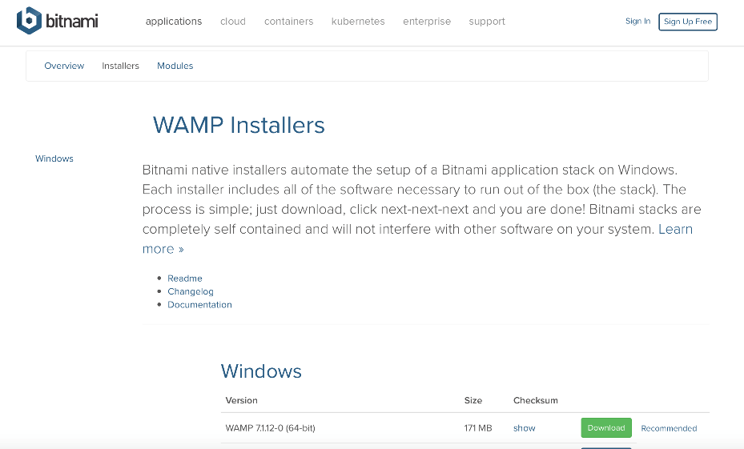

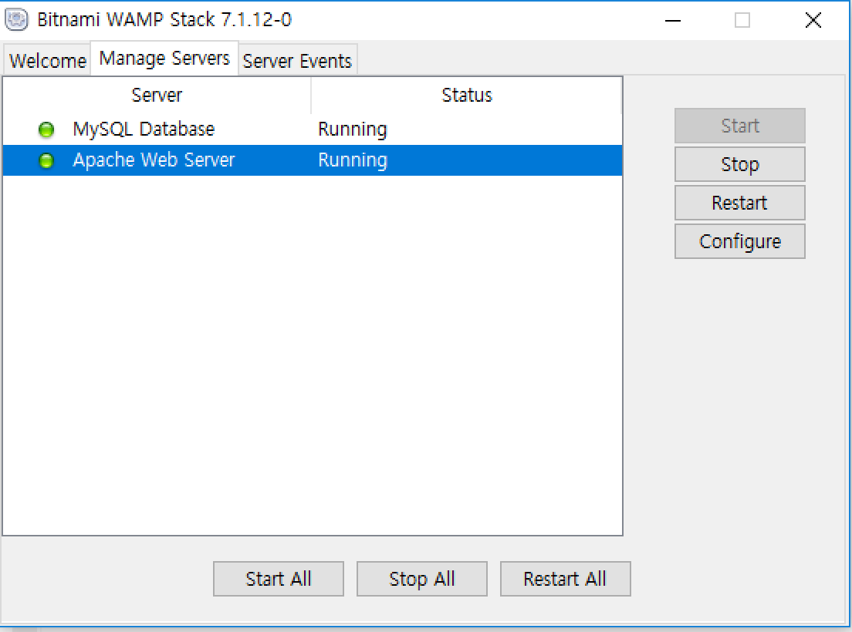

If you install WAMP on the above page, the server will be set up automatically and you will be able to set a MySQL password during the installation process.

The above program will solve the inconvenience when installing MySQL.

### 2.1.2 ATOM

We used Atom as a tool to build php.

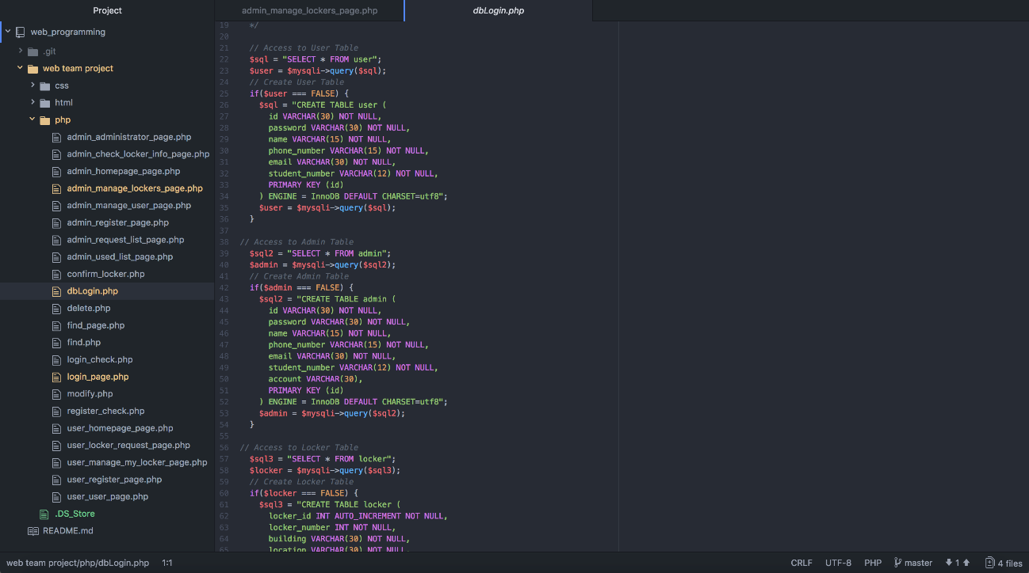

Atom lets you type letters in different colors for each type, making it easier to recognize, and it provides convenience when you set up the folder itself and load it into a project.

### 2.1.3 Github & Gitkraken

We shared our team data with Github, and GitKraken made it easier for us to use Github.

GitKraken provide function you to set local folders so that individuals can distinguish between GitKraken's up-folder and after- work folders.

When you make an update, you can input the contents of the update so that users can easily distinguish the data.

In addition, with the support of Branch function, if users were working individually, they could work with the branch to do their own work, and then we could work with the concept of making a complete copy of the function by weaving with Master.

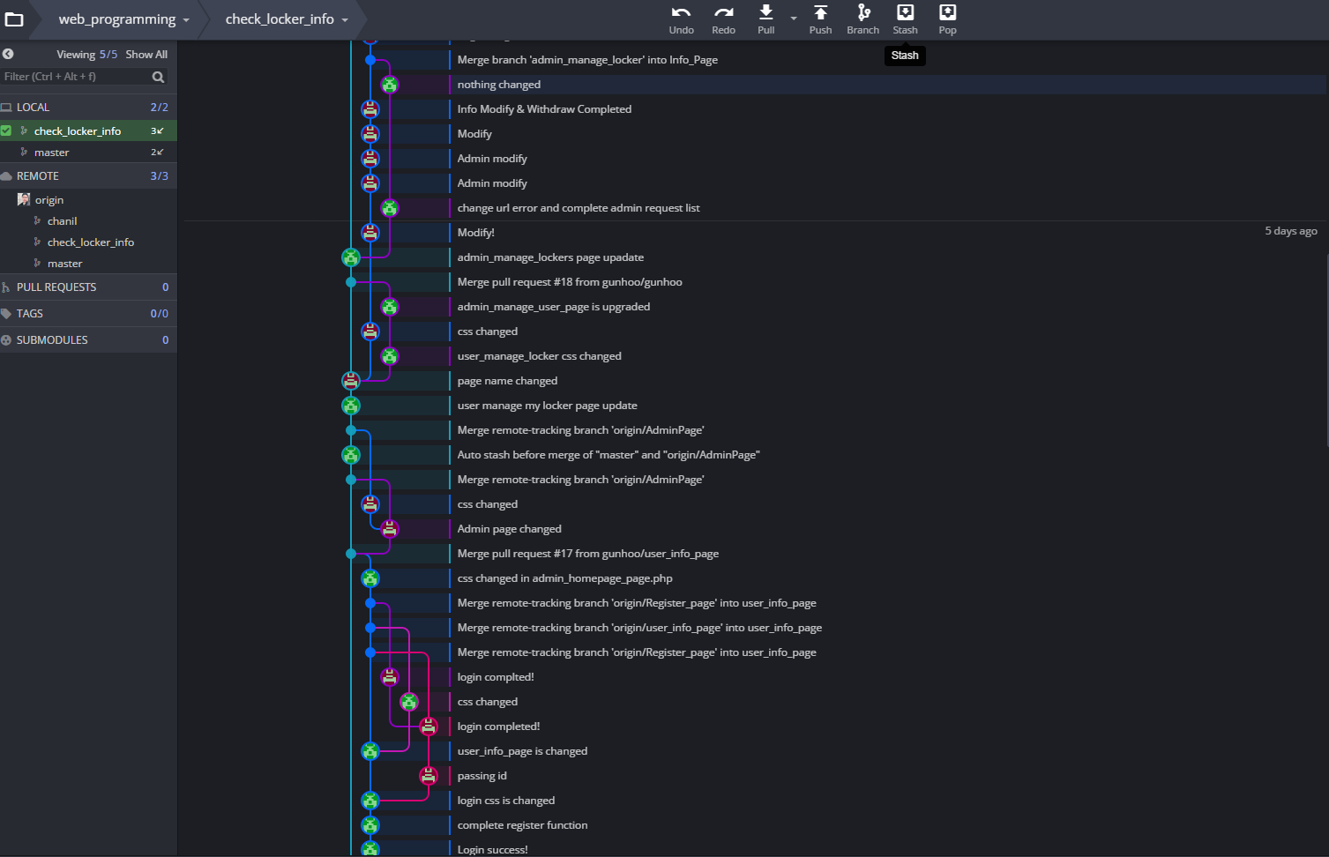

<https://github.com/gunhoo/web_programming>

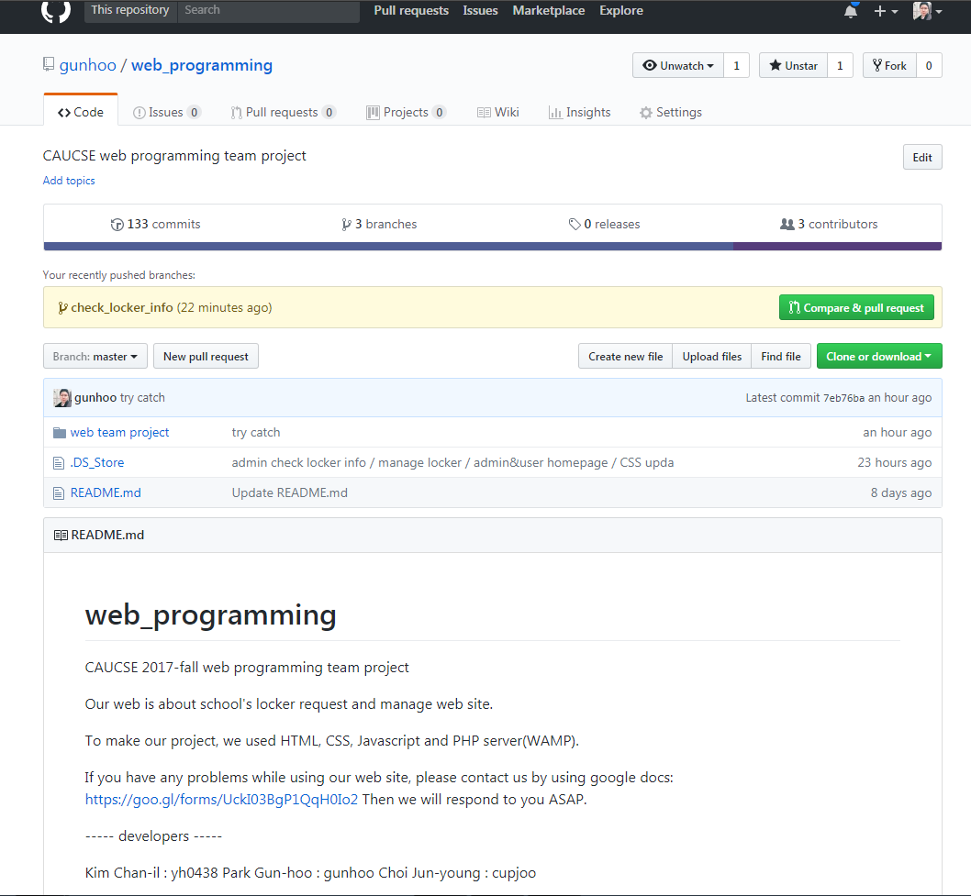

## 2.2 How to build software

We created this software using php, which we learned in web programming lecture.

1. First, we made an approximate page structure with html and css.

Since we needed to move between pages afterwards, we decided on the title syntax of the page.

1. We made all the pages in php while configuring the functions to use the DB.
2. We got a bug in the finished pages.
3. After fixing all the bugs, we have made minor updates to make them easier to use.

## 2.3 Bug tracking process

We used github, so we specify the bugs at gitkraken.

Not only we use git, but also we use kakao talk messenger, so that we can communicate with that.

We used Chrome browser and Internet Explore 11.

We used atom tools so that we can bug tracking by atom tools and browsers’ F12 debugger.



# Software Description

## 3.1 Modules & interfaces

We use Modules like below.

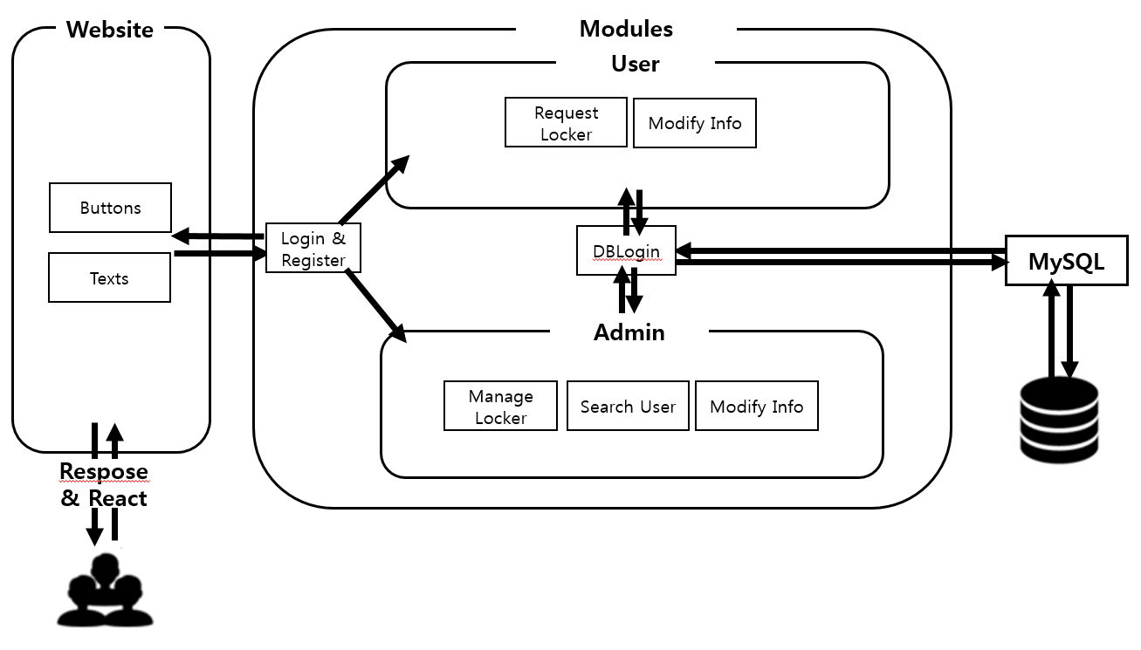

### 3.1.1 Login & Register

To use our website, you need to register.

Your personal information is stored in our DB server and we use it for checking if you are a user or manager, lost ID / password search.

### 3.1.2 DBLogin

You can connect to MySQL with DBLogin module.

### 3.1.3 Modify Info

User and administrator can check their personal information and modify it.

### 3.1.4 Request Locker

To use locker, you need to request.

If you press the ‘Locker Request’ button menu at the top, you can go to the webpage where you can request locker.

There you can check the locker location and information and you can request your own locker.

### 3.1.5 Manage Locker

If you are an administrator, you can add new lockers for new location.

You can modify the expiry-date & rental-fee etc. And you can also delete the lockers.

### 3.1.6 Search User

If you are an administrator, you can find an user with his/her student number or id and can check a part of their personal information.

## 3.2 Source code structure

## 3.3 Design Changed

### 3.3.1 Manage user in admin page

Original Design in Admin Changed Design

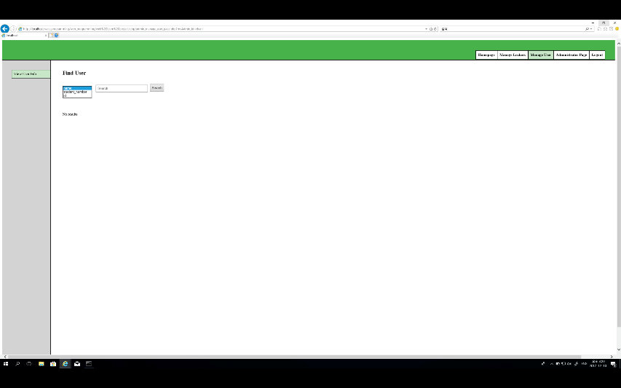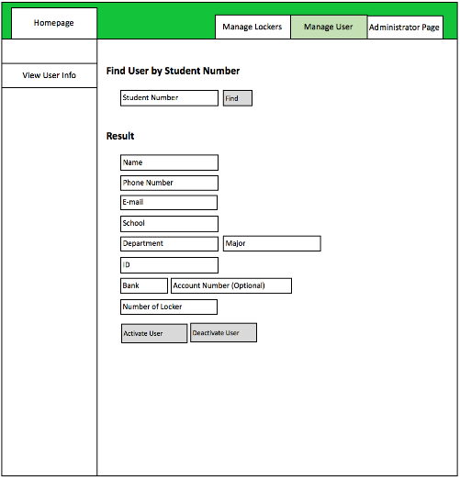

We added Manage user menu on the top.

So we can search not only by student number, but also id and name.

### 3.3.2 Requested list in admin page

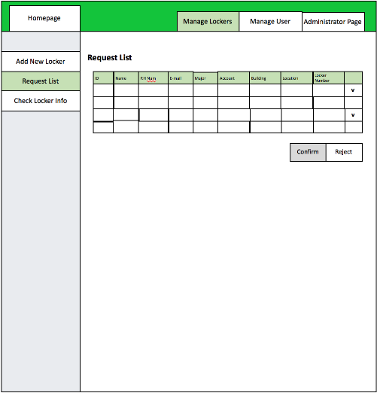 original request list

Changed request list

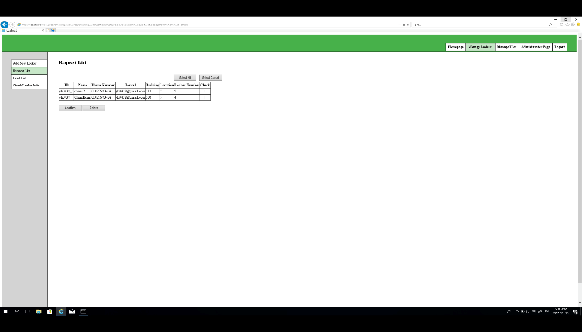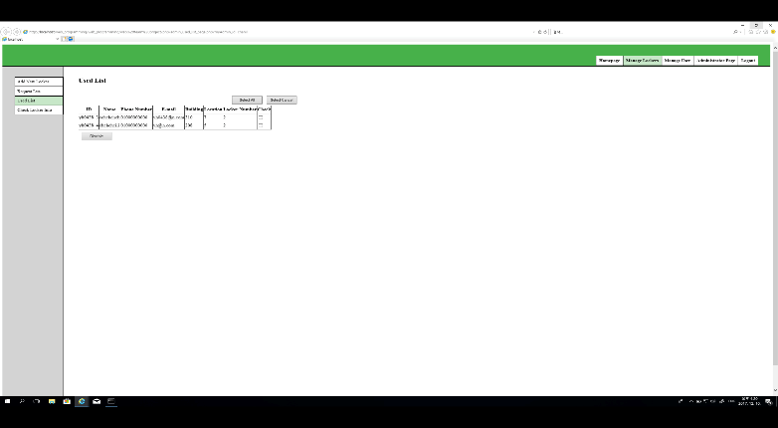

We add used list. So we can disable the user using the locker.

And we add select all and select cancel button. So we can choose check boxes more easily.

### 3.3.3 Logout function

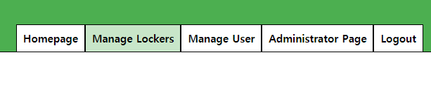

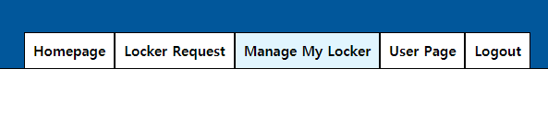

We put logout menu on the top because we cannot logout which we designed before.

### 3.3.4 Locker display

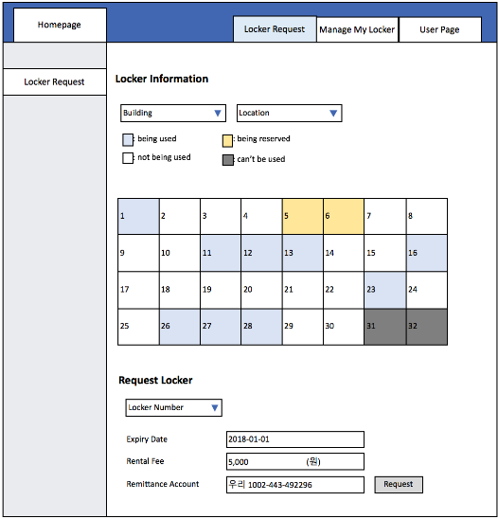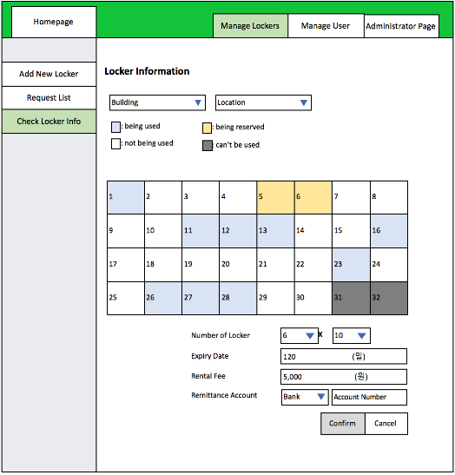

We deleted above display of locker information.

# Test

## 4.1 Test scenario in user mode

### 4.1.1 Register

1. Click User Register
2. Write the information
3. Click register
4. Login as an user
5. Check the User DB

### 4.1.2 Request locker

1. Login as an user
2. Click Locker Request menu
3. Select the options that you want to request
4. Request locker
5. Check the Locker DB or Check the Request List on admin page

### 4.1.3 Manage my locker

1. Login as an user
2. Click Manage my locker menu
3. See what happens

### 4.1.4 Manage Info

1. Login as an user
2. Click User page menu
3. You can modify your information
4. You can withdrawal your id.

## 4.2 Test scenario in admin mode

### 4.2.1 Register

1. Click Admin Register
2. Write the information
3. Click register
4. Login as an user
5. Check the User DB

### 4.2.2 Add new locker

1. Login as an admin
2. Click Add new locker menu
3. Write the information about lockers
4. Click add button
5. Check the Locker DB or Click Check locker info menu

### 4.2.3 Requested locker Confirm and Reject

1. Login as an admin
2. Click Request list menu
3. You can see the requested locker
4. Click the check boxes and click confirm or reject button

### 4.2.4 Used locker Disable

1. Login as an admin
2. Click Request list menu
3. You can see the requested locker
4. Click the check boxes and click confirm or reject button

### 4.2.5 Check locker info and Modify

1. Login as an admin
2. Click Check locker info menu
3. Select building and location what you want to check information.
4. You can see the information of locker you choose, and you can also modify or delete.

### 4.2.6 Find user

1. Login as an admin
2. Click Manage user menu
3. You can find user by name, student number, and id

### 4.2.7 Manage Info

1. Login as an admin
2. Click Administrator page menu
3. You can modify your information
4. You can withdrawal your id.

## 4.3 Test results in user mode

### 4.3.1 Register

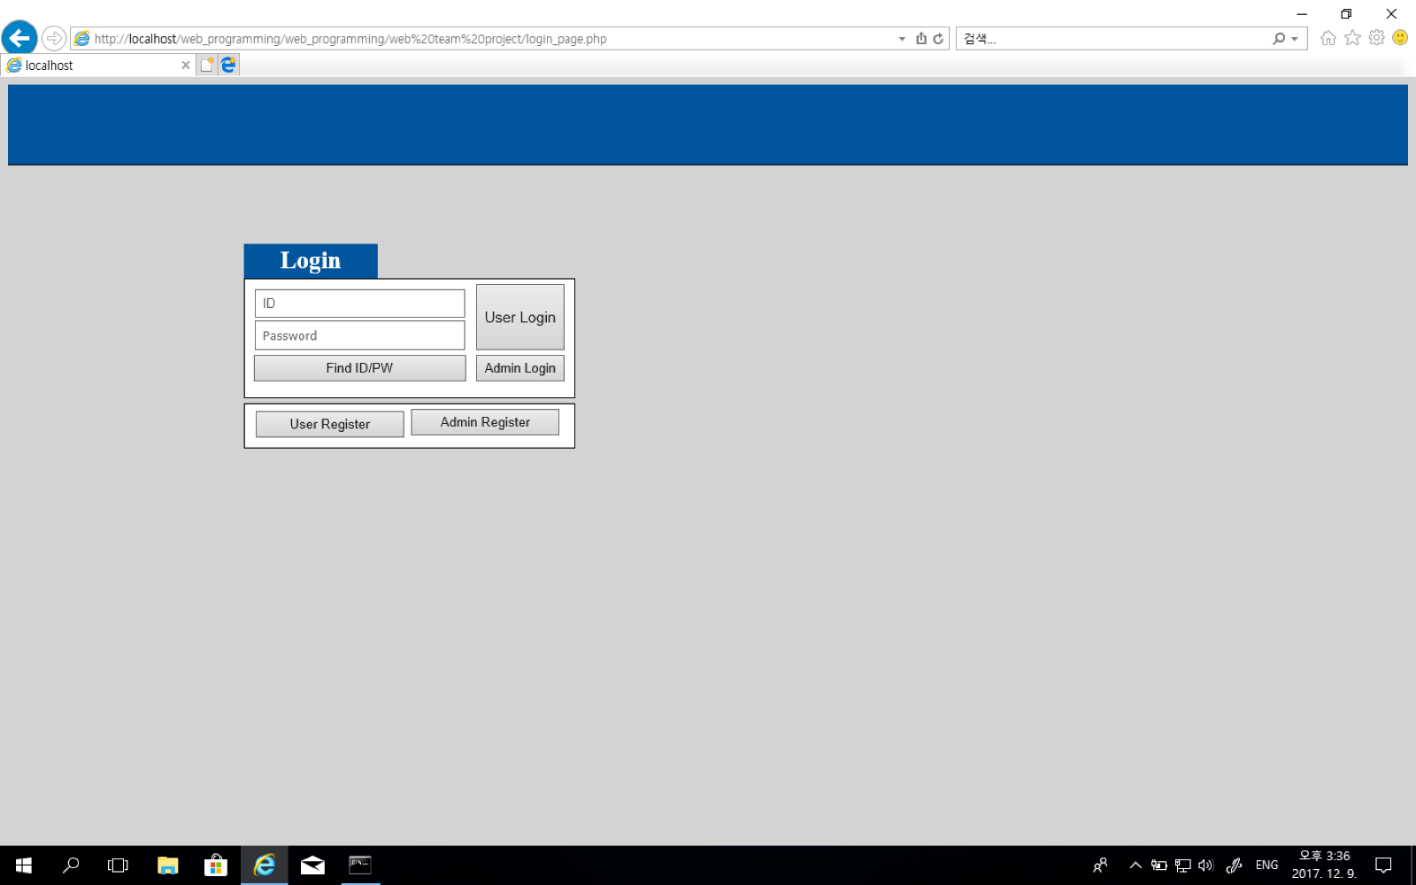

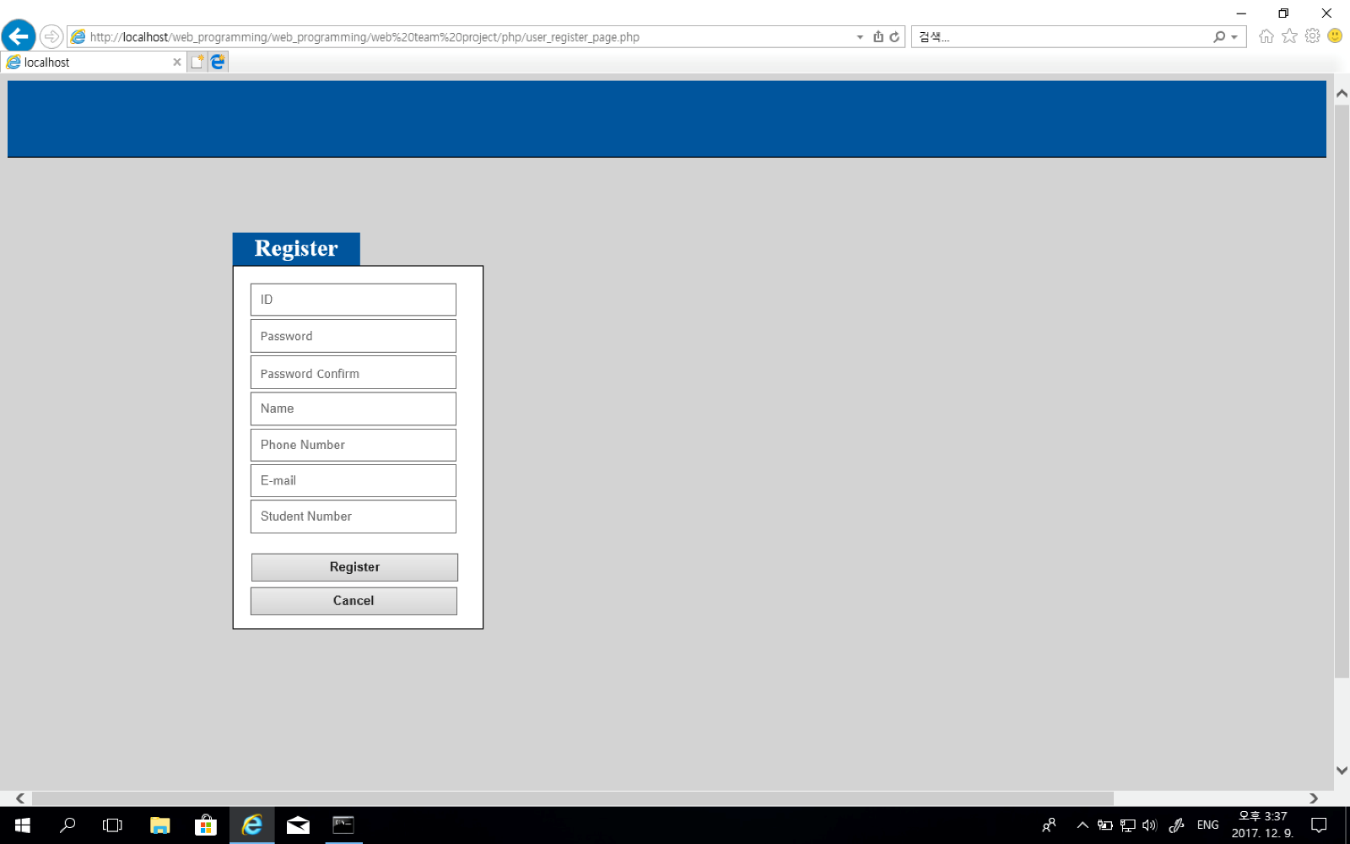

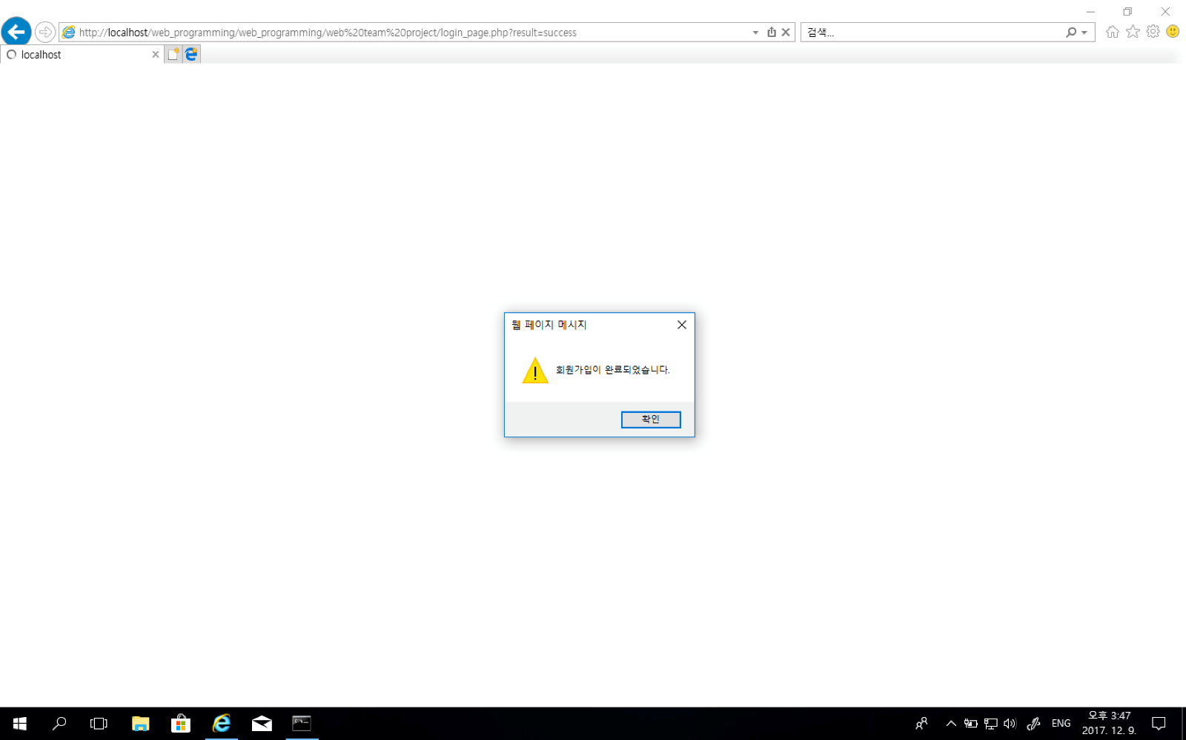

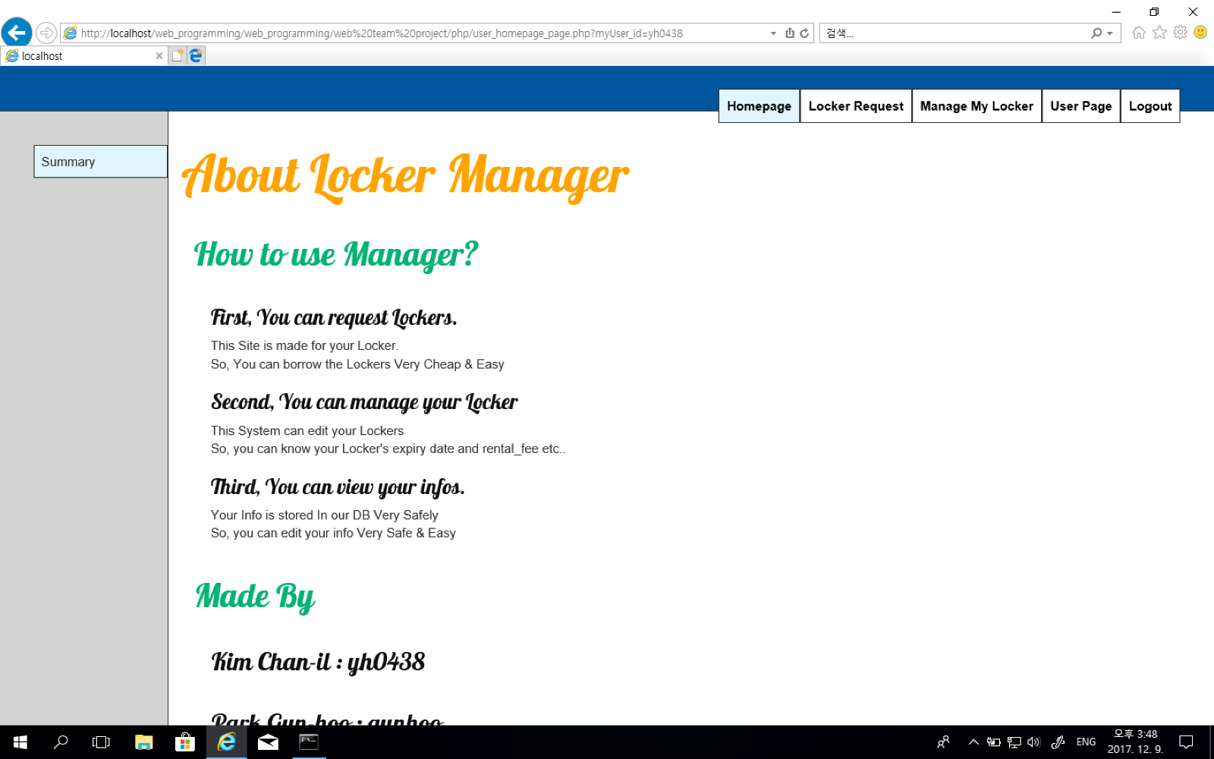

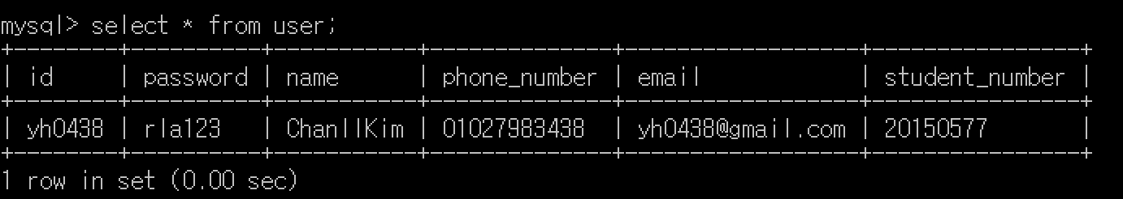

### 4.3.2 Request locker

Once you choose an locker then we show you the locker info and request button

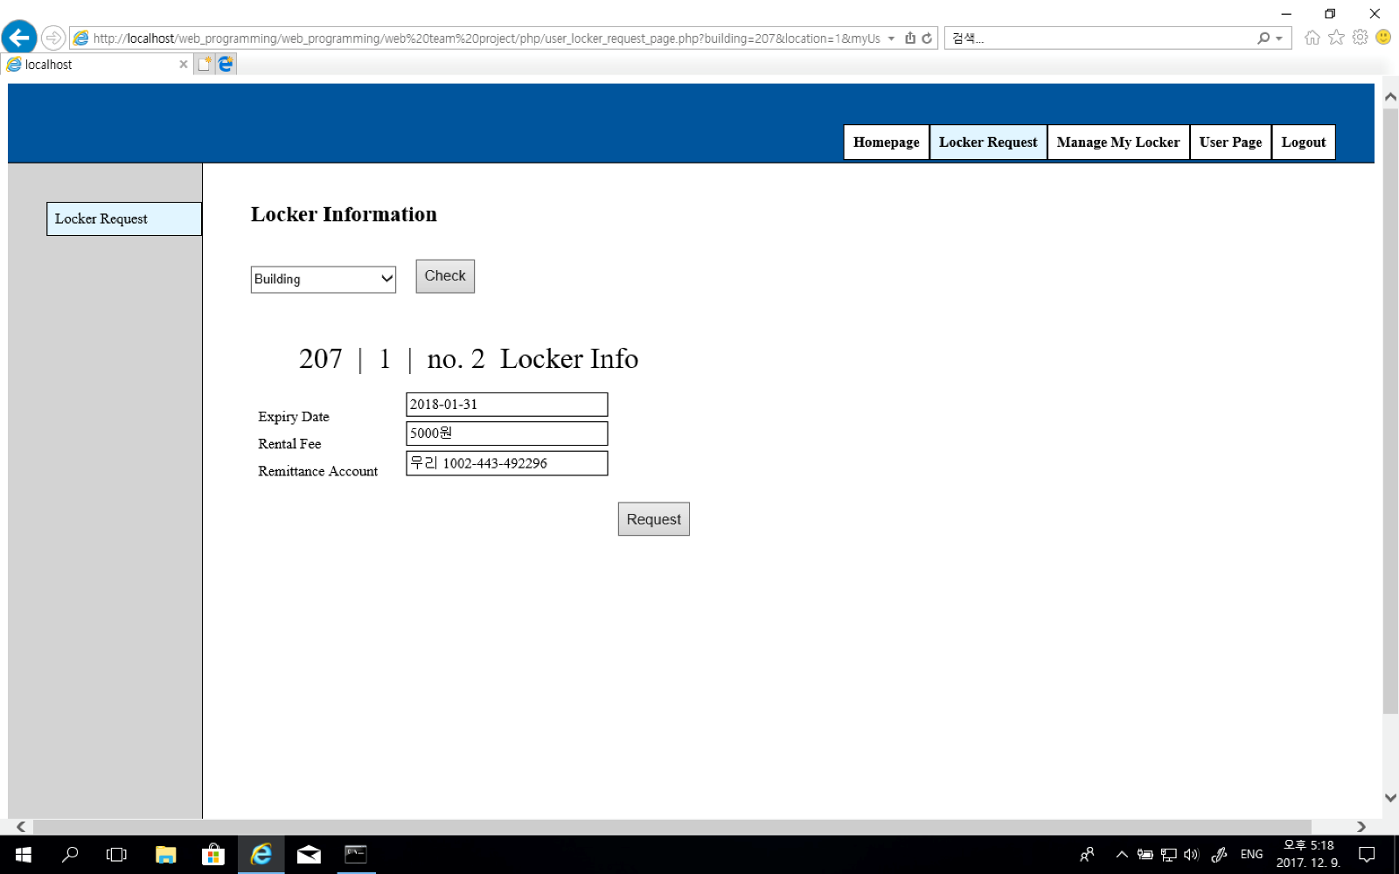

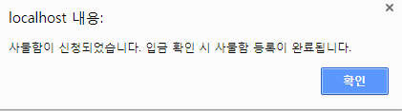

If you already request or use your locker, then error alert will be shown.

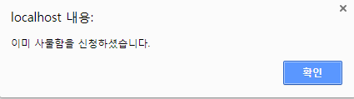

### 4.3.3 Manage my locker

If you are request an locker :

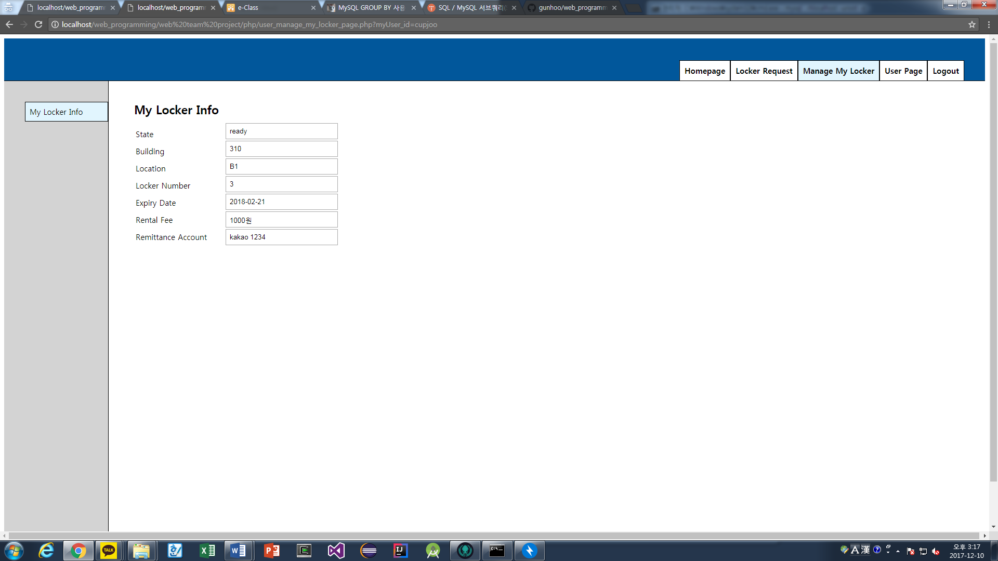

If you are not request an locker :

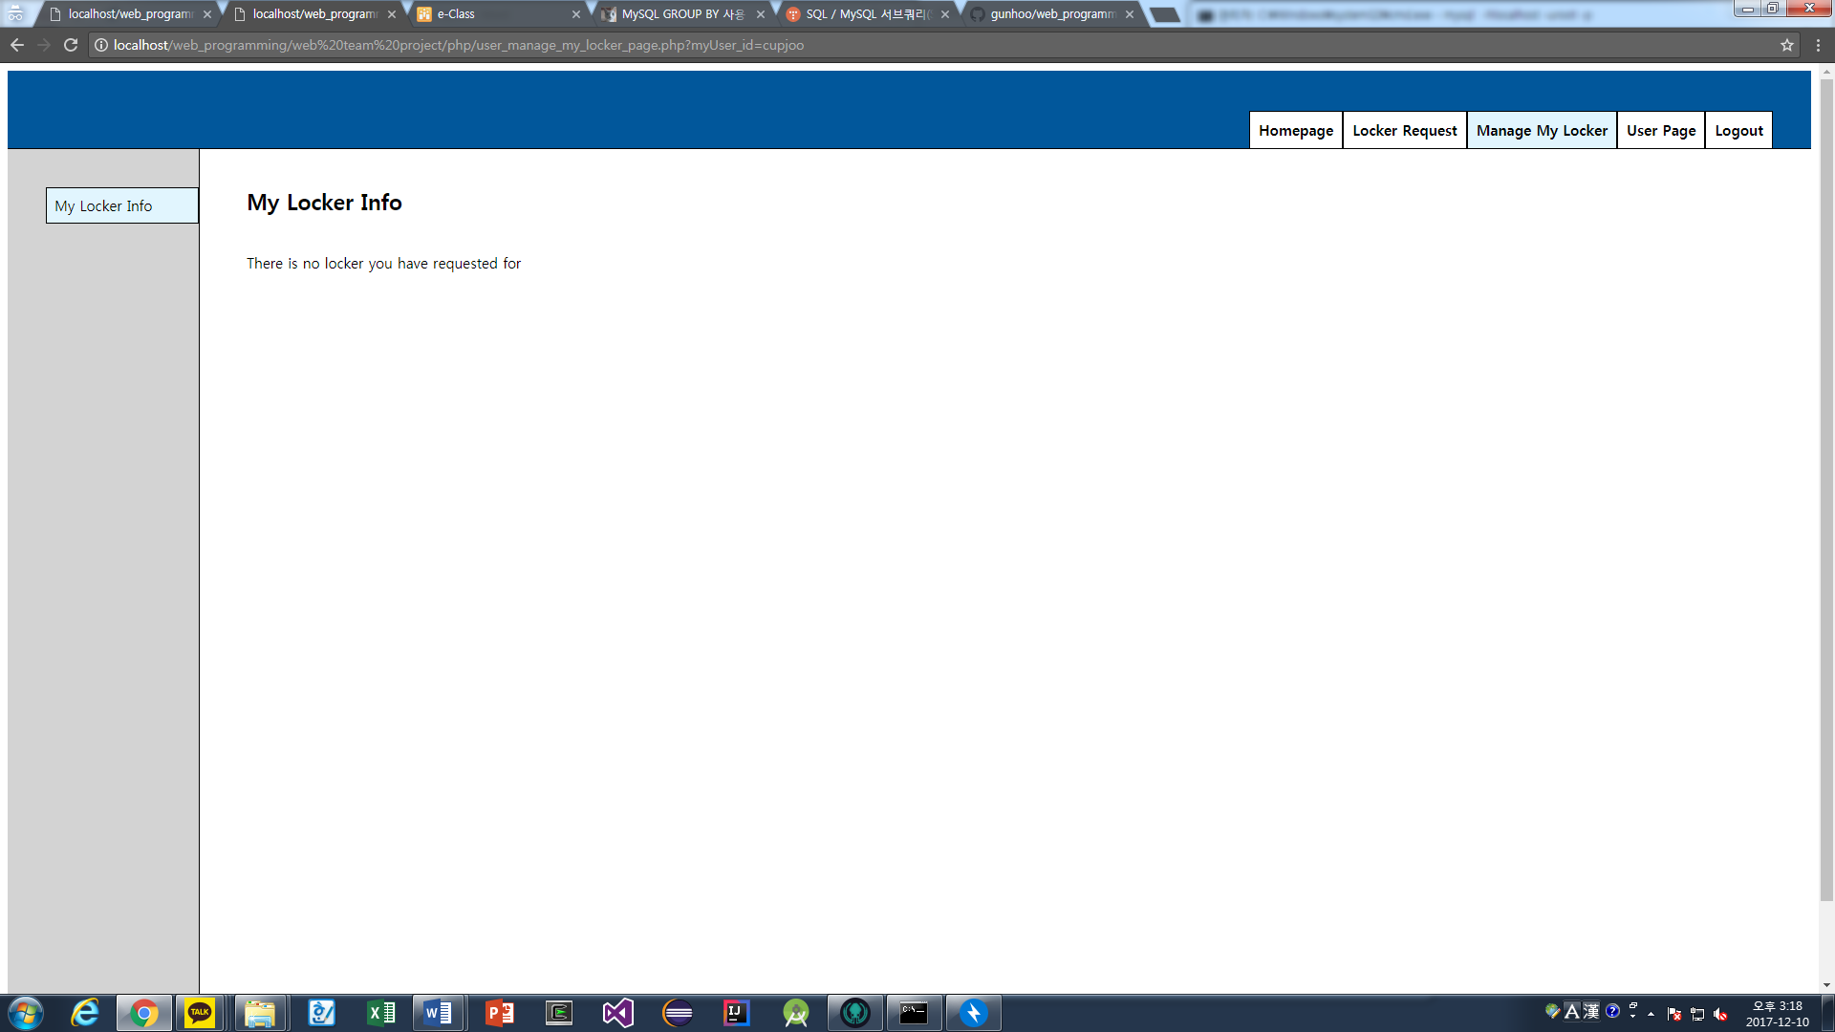

### 4.3.4 Manage Info

User page

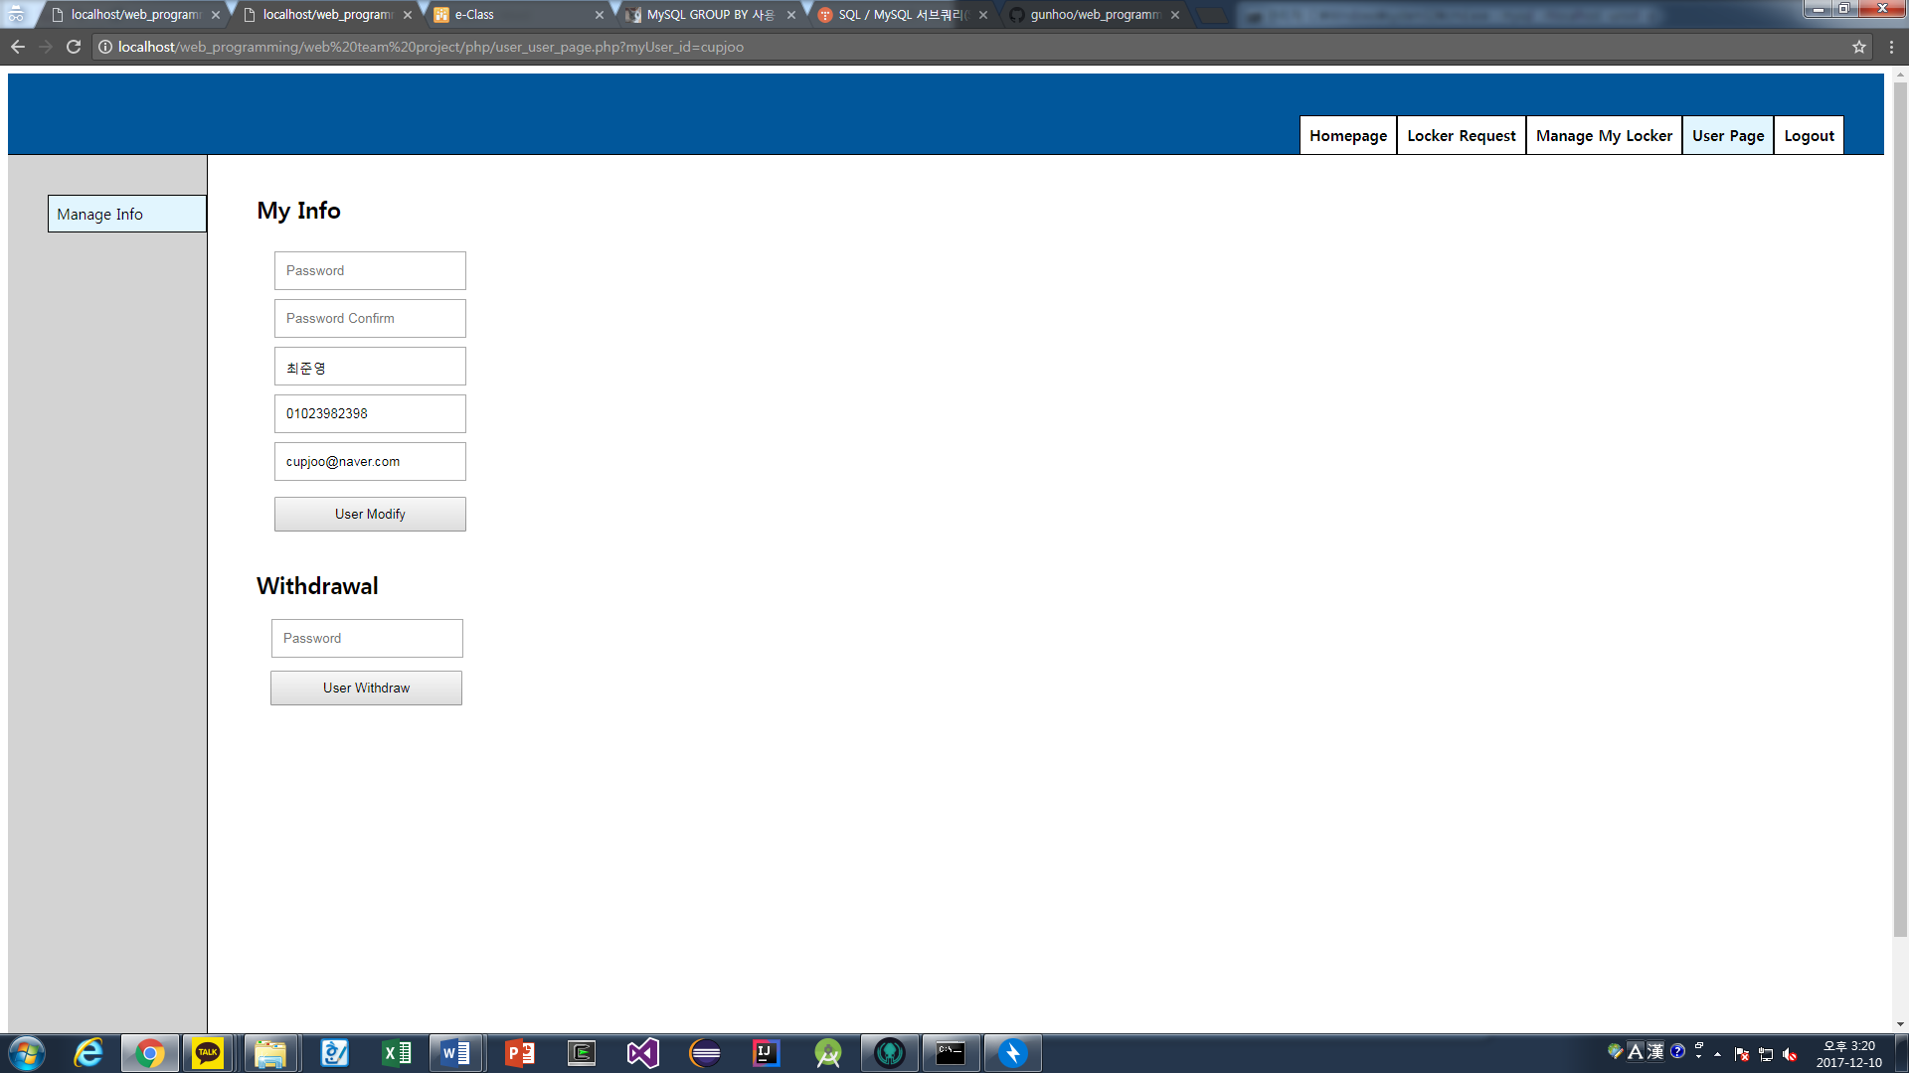

You entered your password and change something

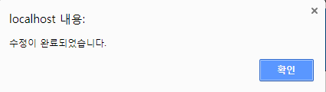

You can see the changed information.

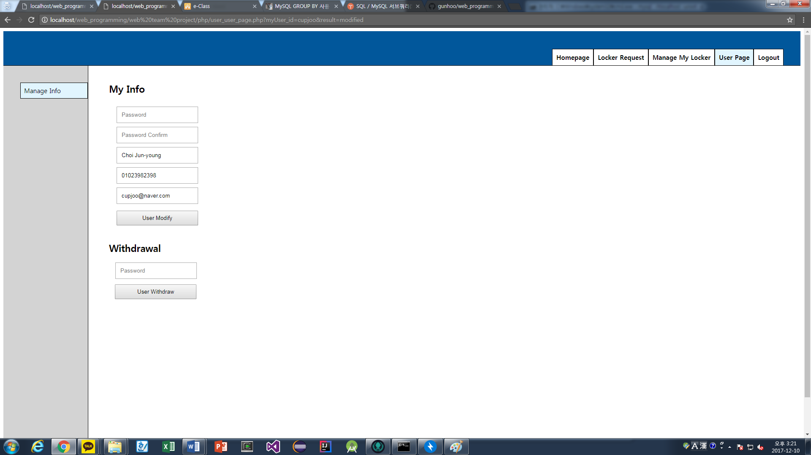

## 4.4 Test results in admin mode

### 4.4.1 Register



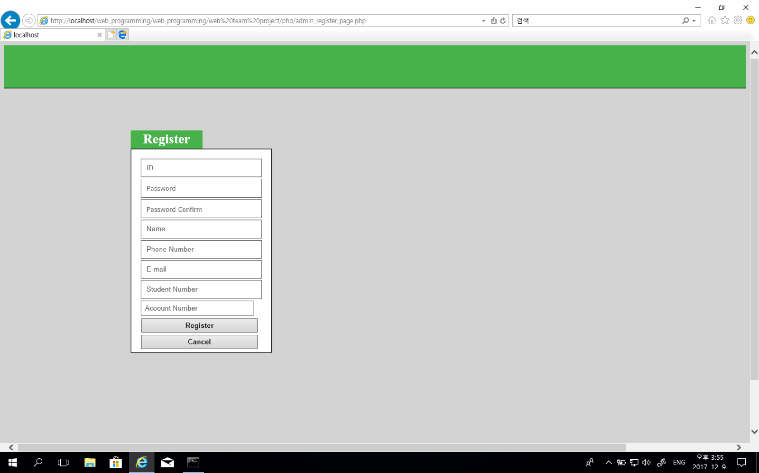

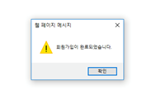

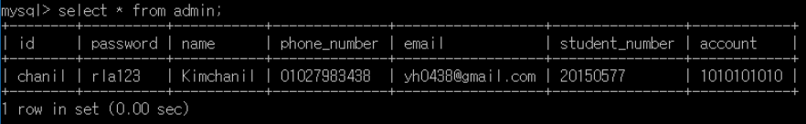

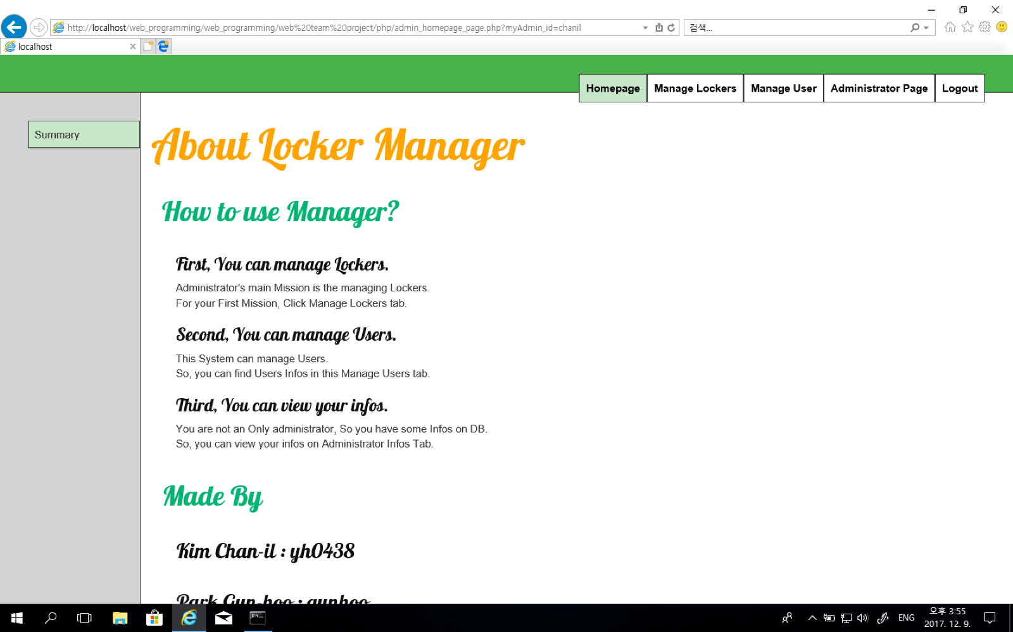

### 4.4.2 Add new locker

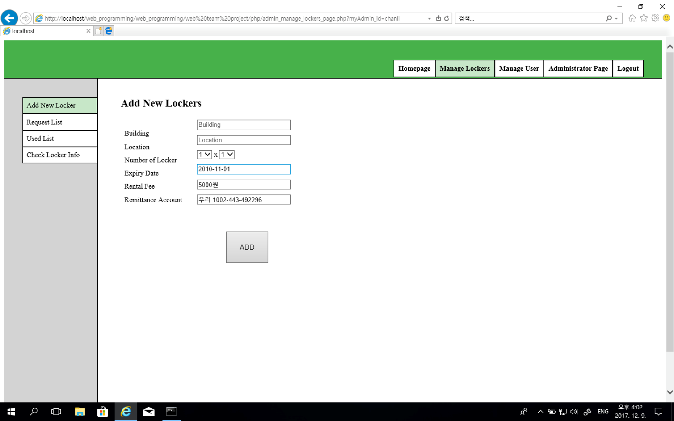

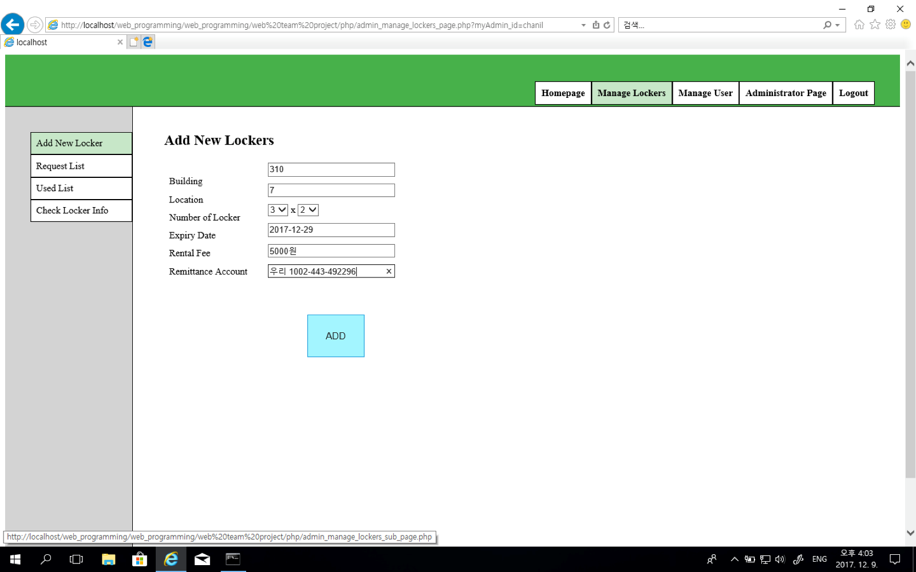

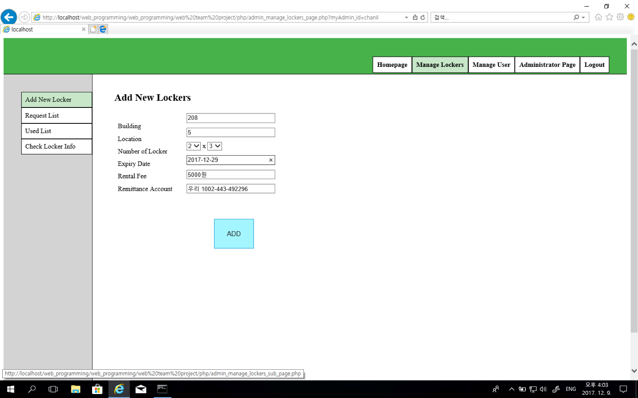

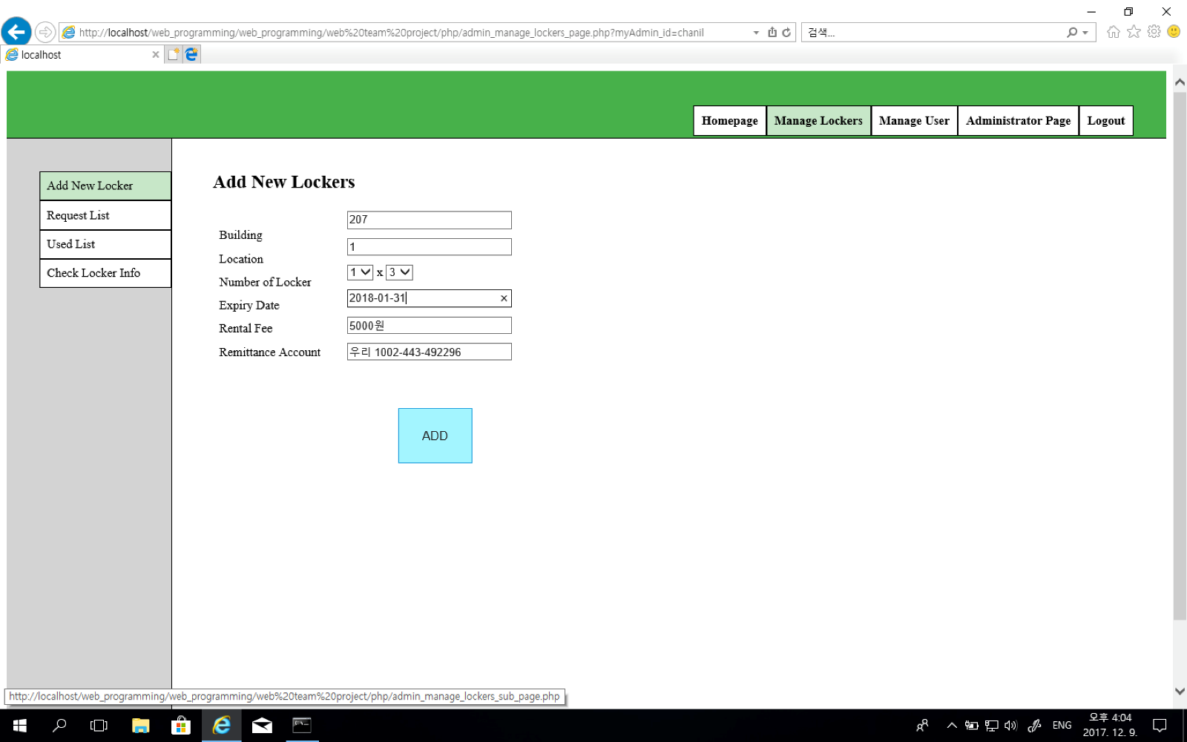

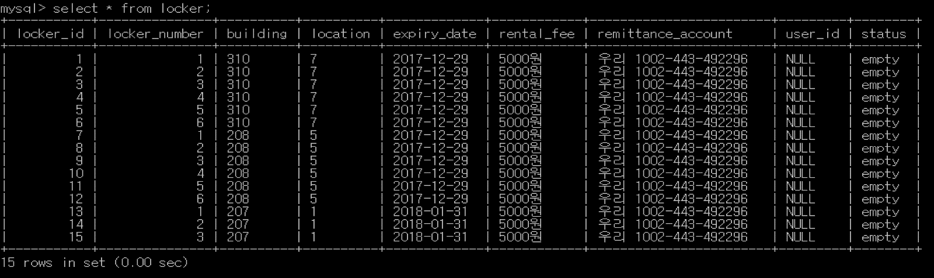

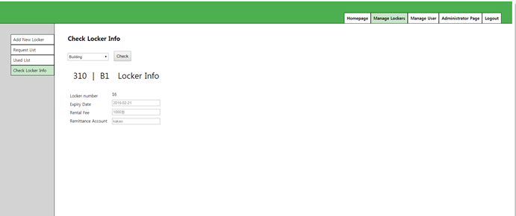

### 4.4.3 Requested locker Confirm and Reject

You can see the requested list.

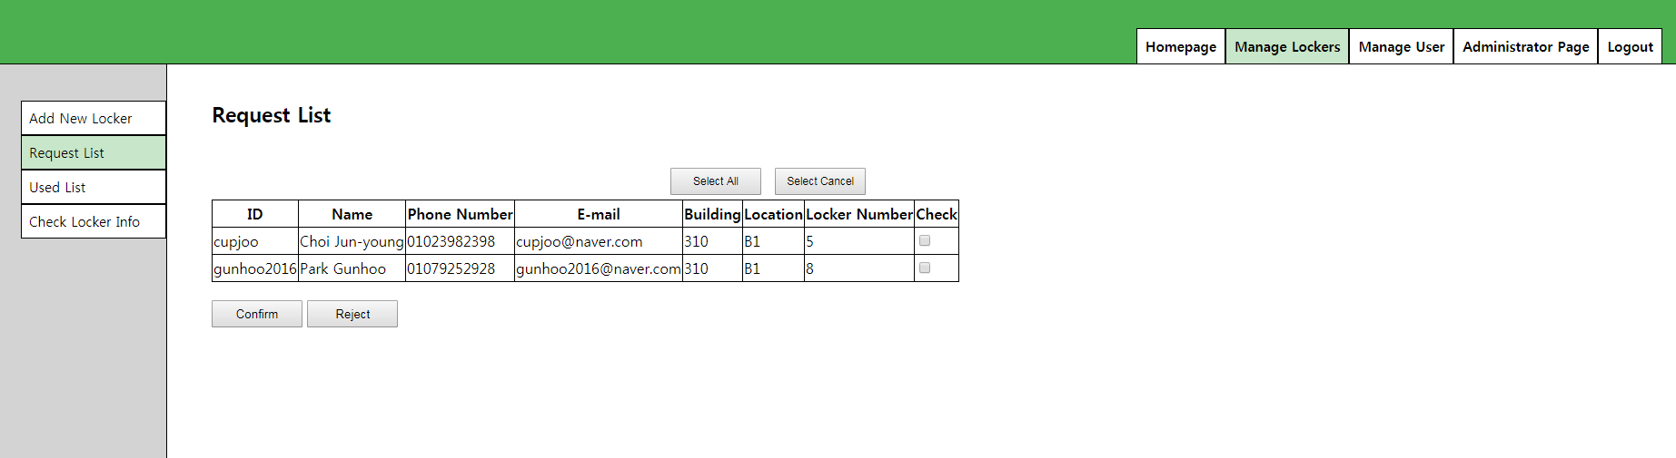

Cupjoo check box selected and click confirm button

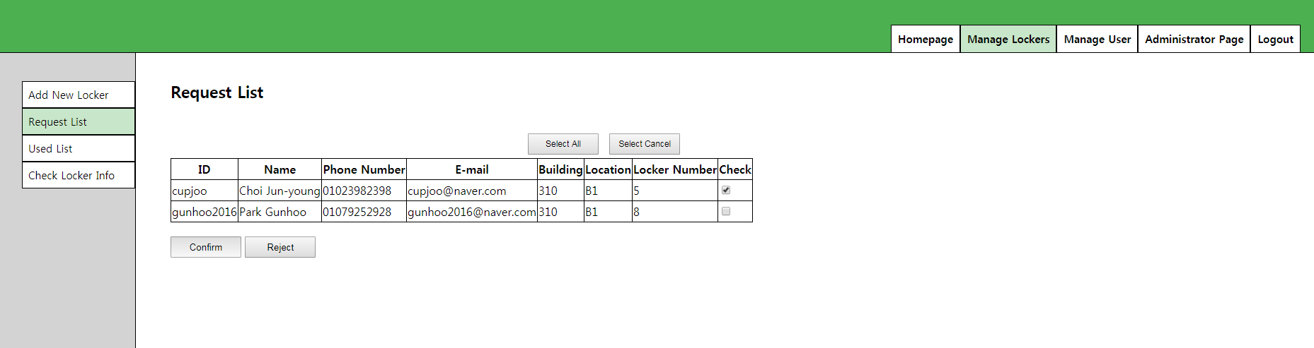

You can see the used list which id is cupjoo

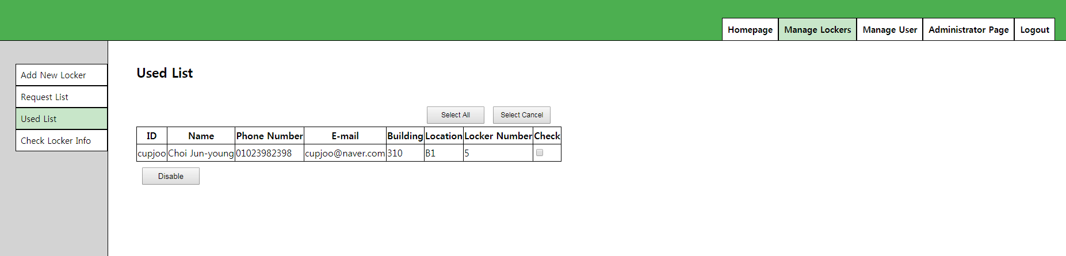

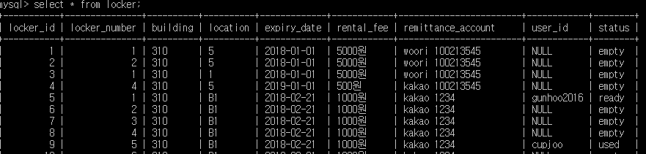

Gunhoo select and click reject button

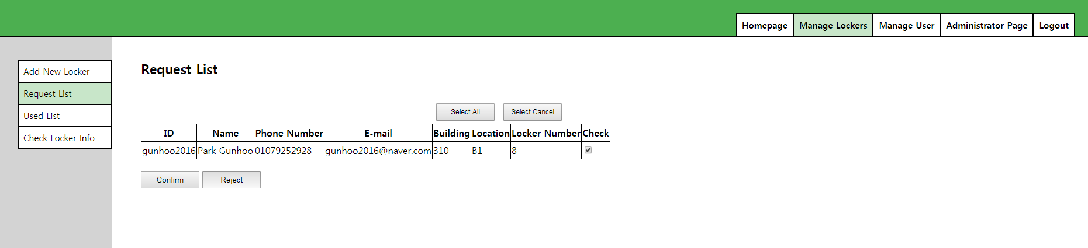

Let’s check database

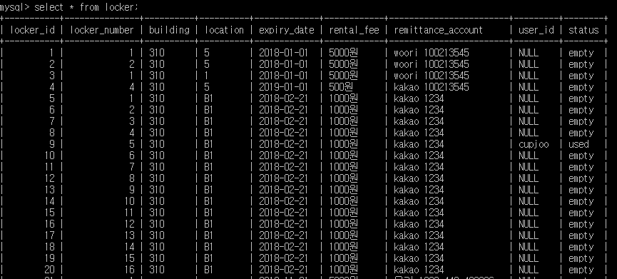

### 4.4.4 Used locker Disable

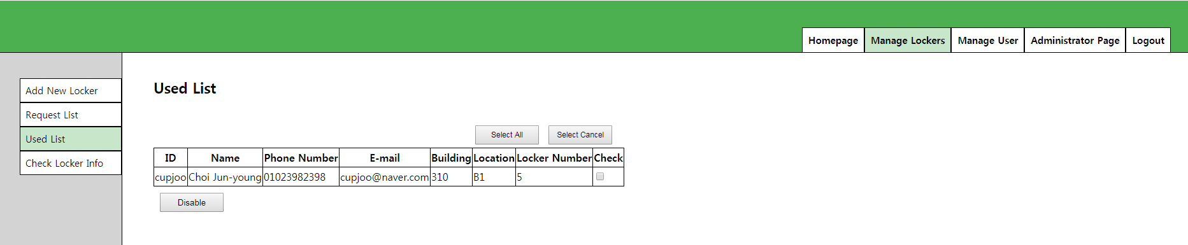

You can check the check box and you can click the disable button.

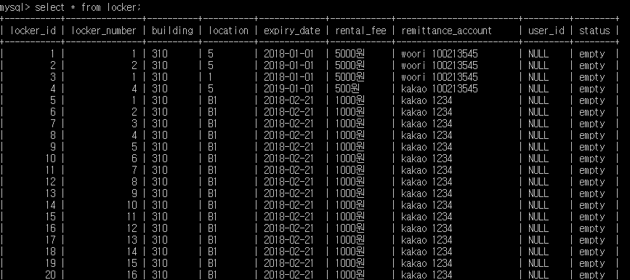

### 4.4.5 Check locker info and Modify

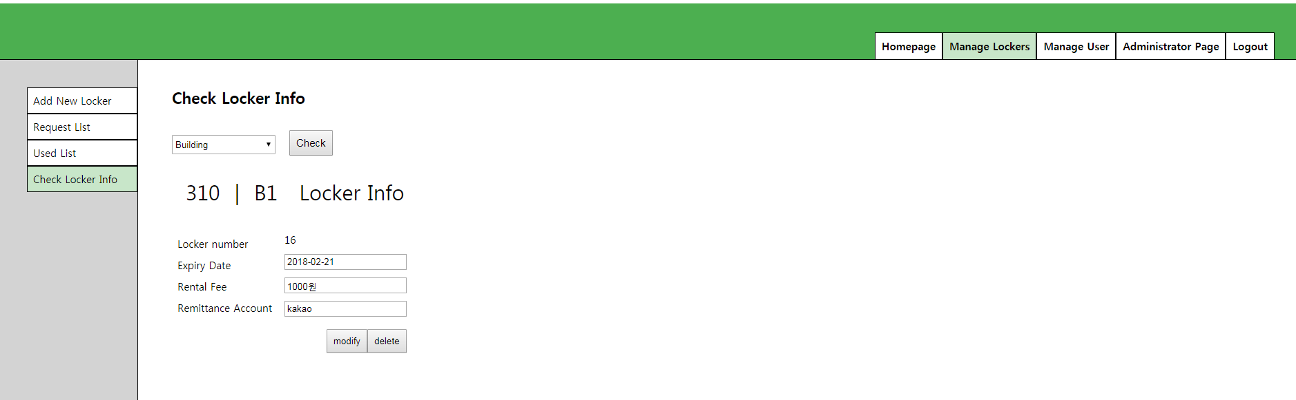

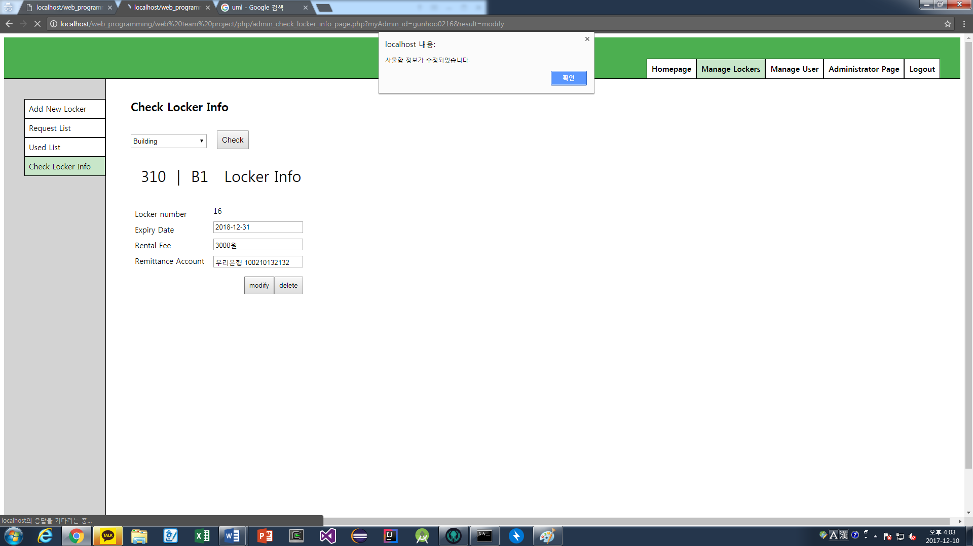

If you delete locker, then we can check if there is a using user.

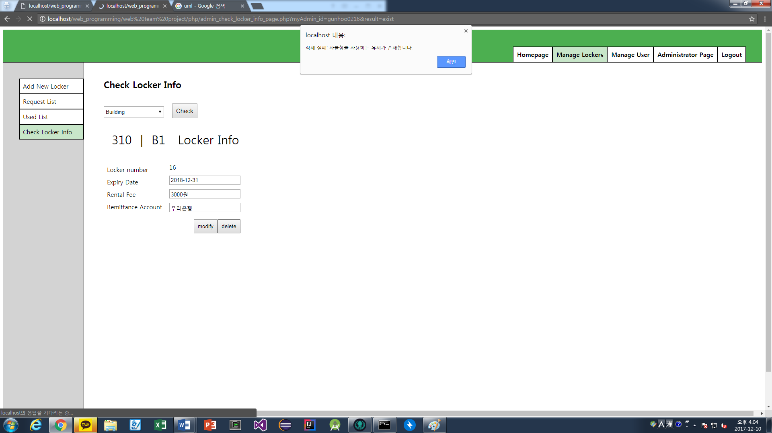

### 4.4.6 Find user

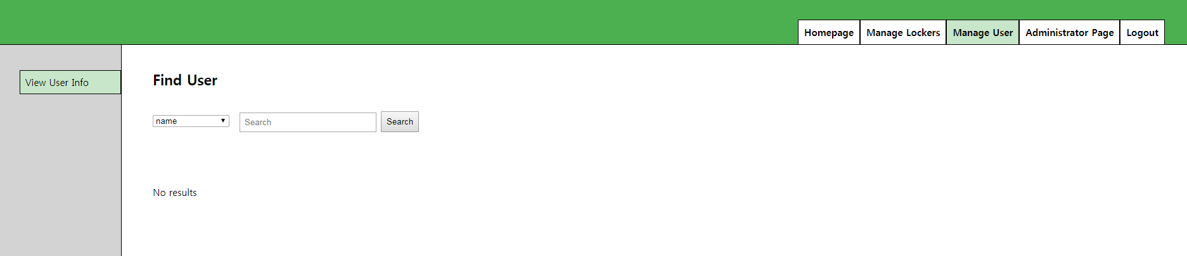

You can search user by name or id or student number.

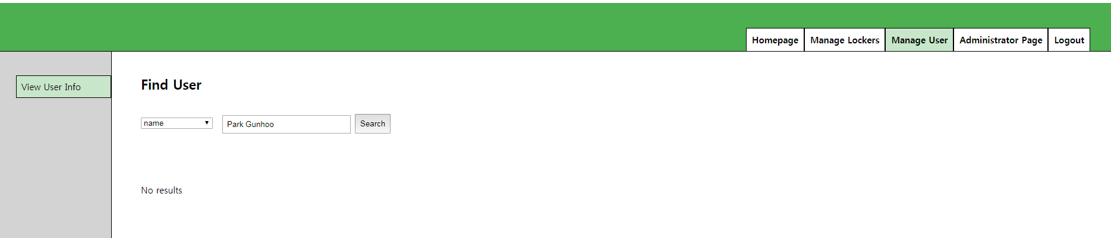

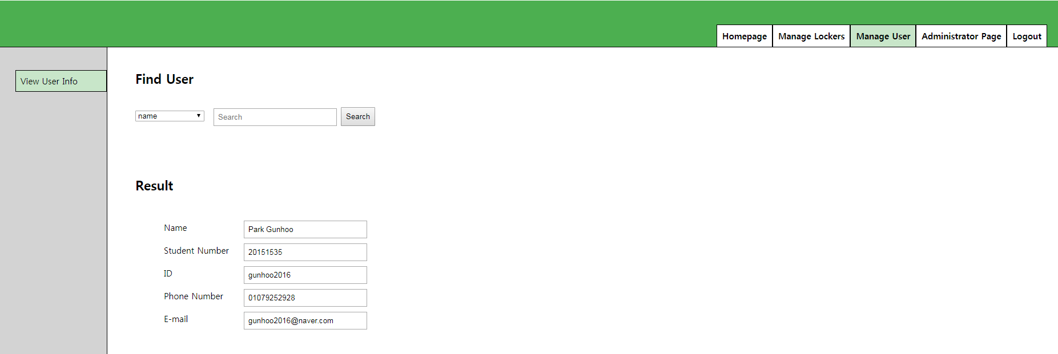

Select student number and enter something

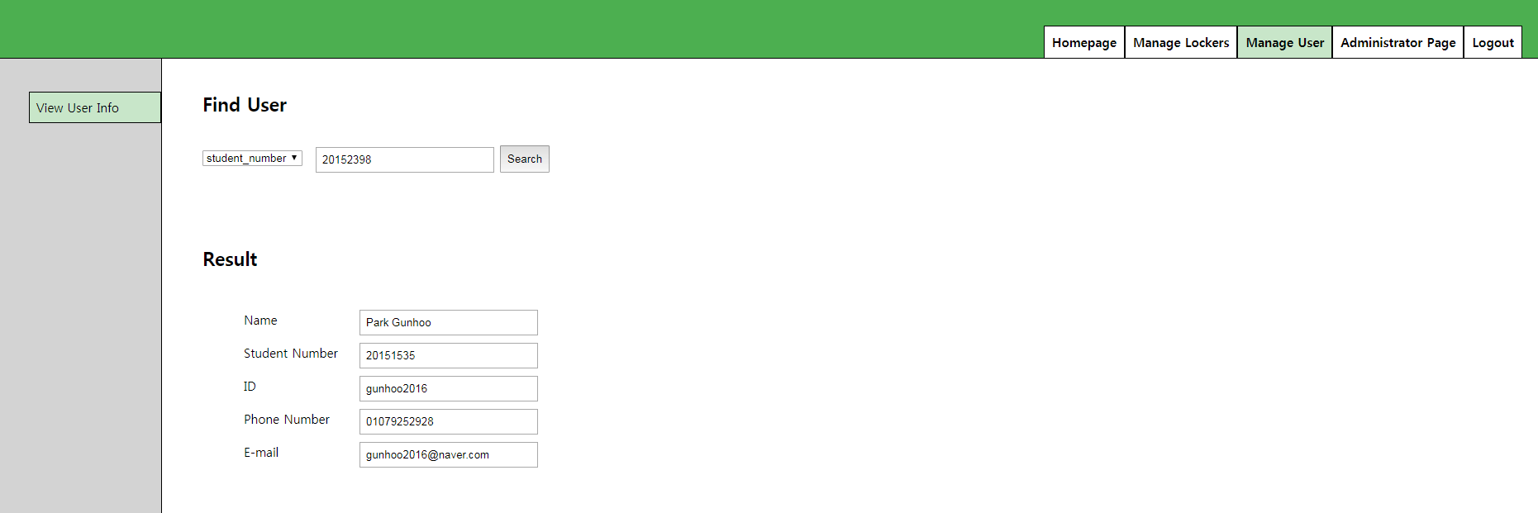

Then results are :

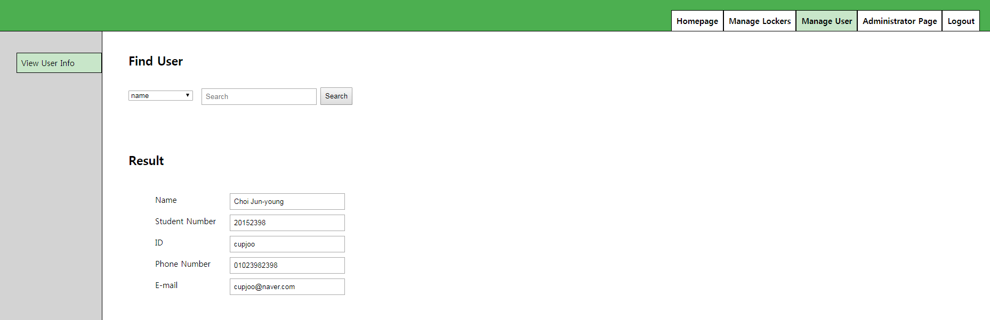

Finally, you can search by id as well.

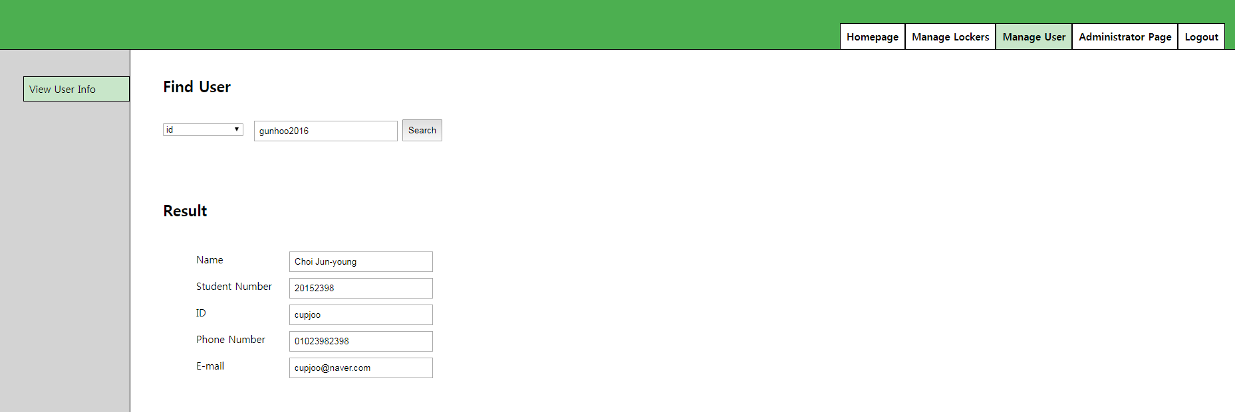

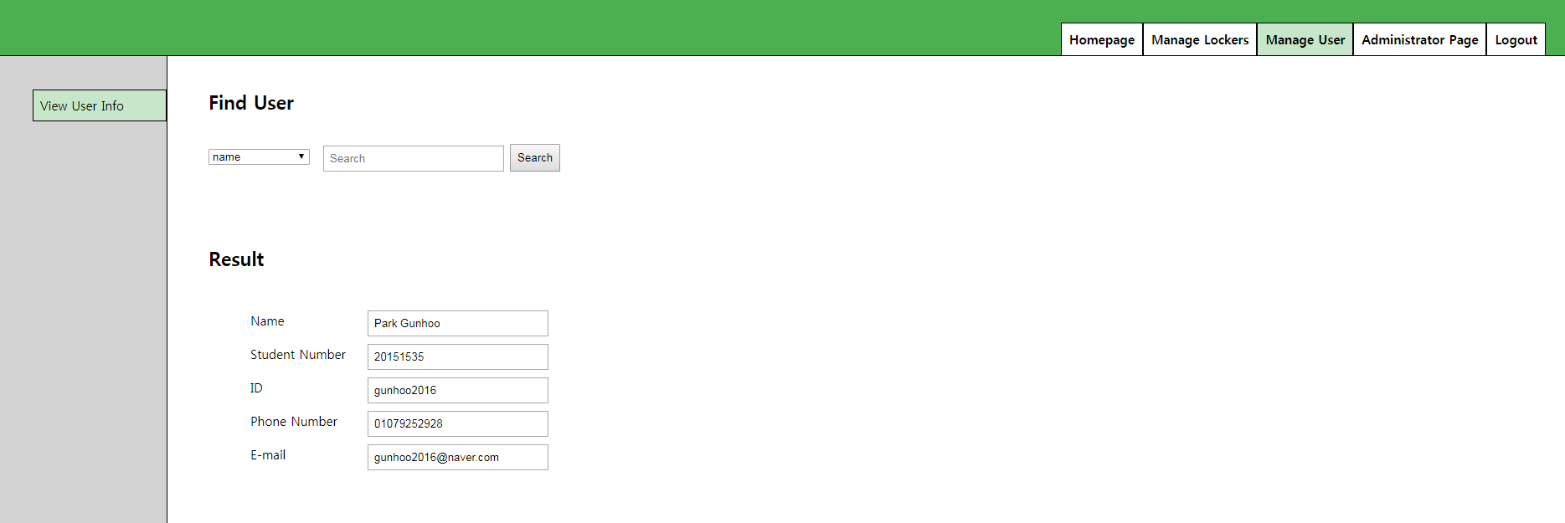

### 4.4.7 Manage Info

You can modify your information same as user and withdrawal as well.

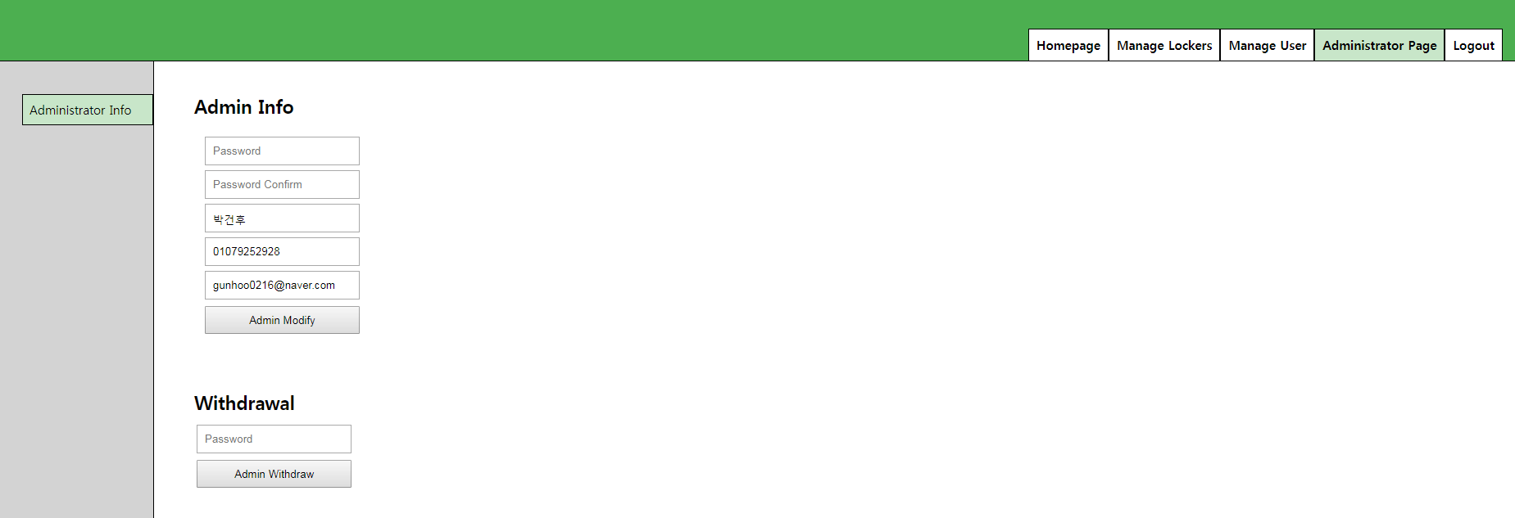

# Conclusion

# References